# In-house NetFlow Collector - Basic Requirements for GNS3 simulation

1. Download GNS3 latest version available (GNS3 2.2.3)
2. Download Virtual Box latest version available (Virtual Box 6.0.14)

# **Importing GNS3 VM in Virtual Box**

1. Download the latest version of GNS3 VM. The file will be in **.ovf** format.

In the **Virtual Box File -> Import Appliance**. The following window will appear. Browse through and choose the **.ovf** file to be imported.

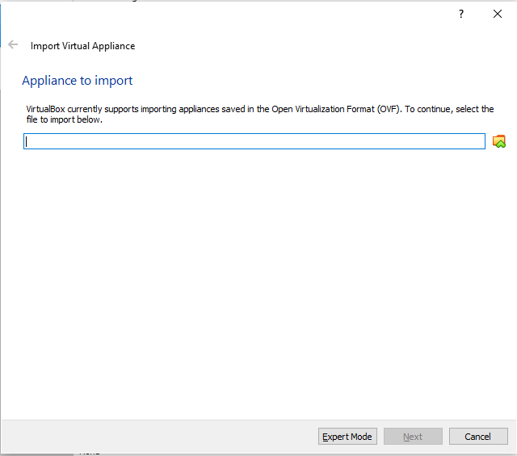

1. Click Next. The following window will appear. Import with the default settings.

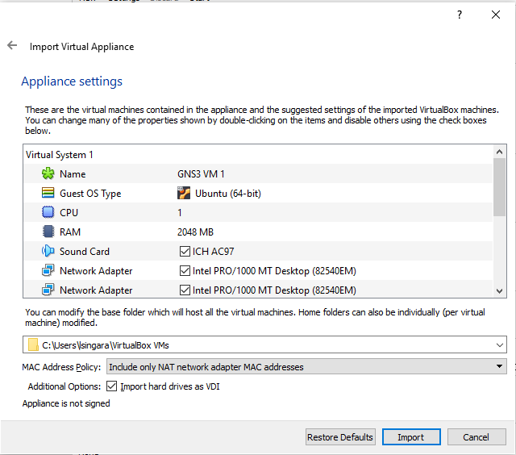

1. Select the Settings Icon in Virtual Box and Select Network option from the left pane. Select the adapters settings for 2 adapters as the below images.

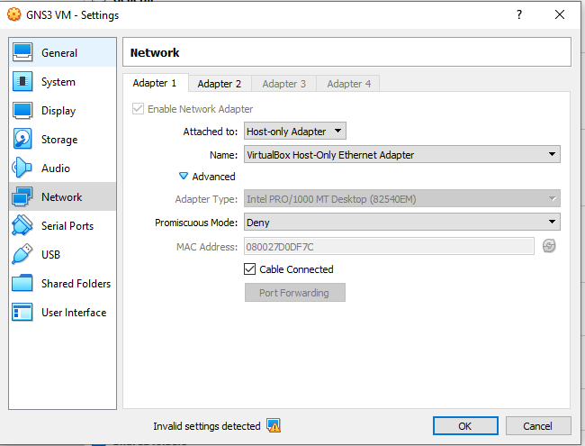

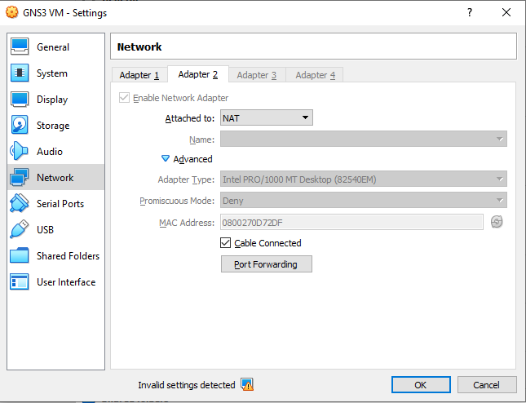

1. For GNS3 VM to get automatically assigned an IP address in the same subnet as the host, Go to **File -> Host Network Manager.** Make sure of the settings as per the below screenshots

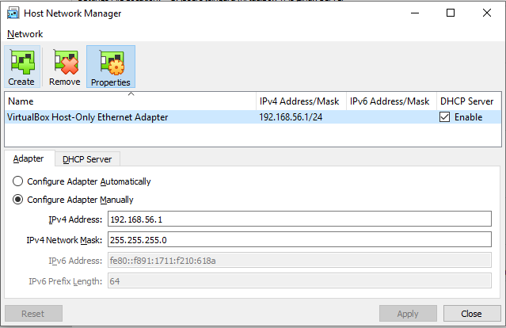

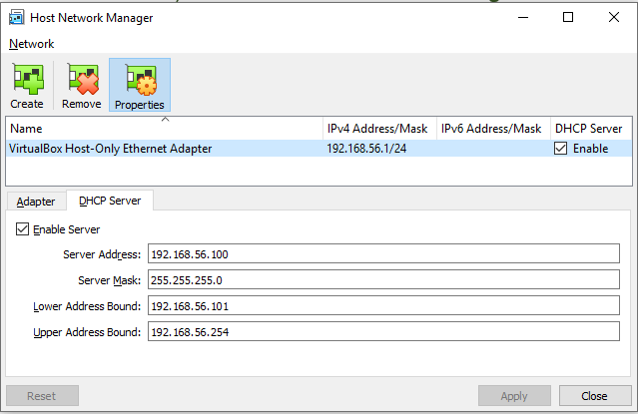

# **Importing GNS3VM in GNS3 GUI and Running Simulations in GNS3 VM**

1. In the GNS3 GUI go to **Edit – > Preferences.** Select GNS3VM in the left pane and give the GNS3 VM preferences as mentioned below.

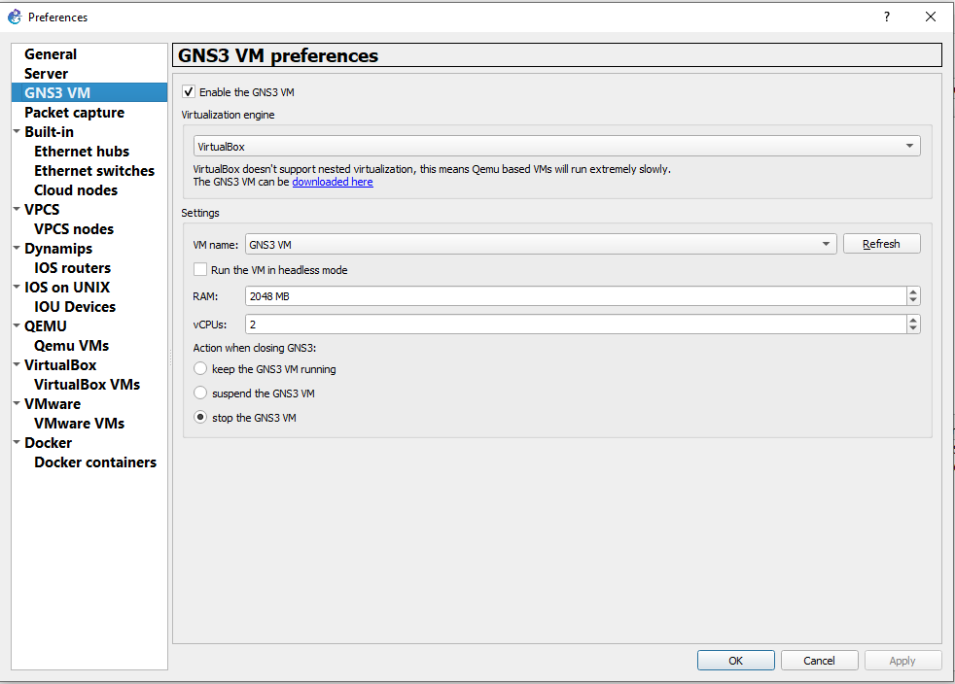

1. To run the simulations in GNS3 VM go to **Help - > SetUp Wizard.** Select the option **Run Appliances in a virtual machine** to run the simulations in GNS3 VM. Choose next for all the pop-up window options and Click Finish.

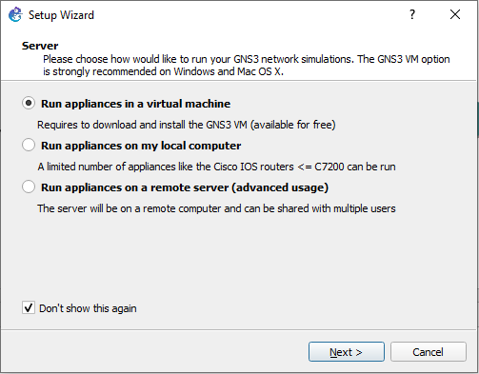

# **To use the Cisco IOS Image in GNS3 GUI**

1. Download the required Cisco IOS image. Go to **Edit - > Preferences .**

In the left pane select **Dynamips->IOS router. Click New.**

In the **New IOS router template** select **Run this IOS router on the GNS3VM** as shown in the below screenshot.Click Next

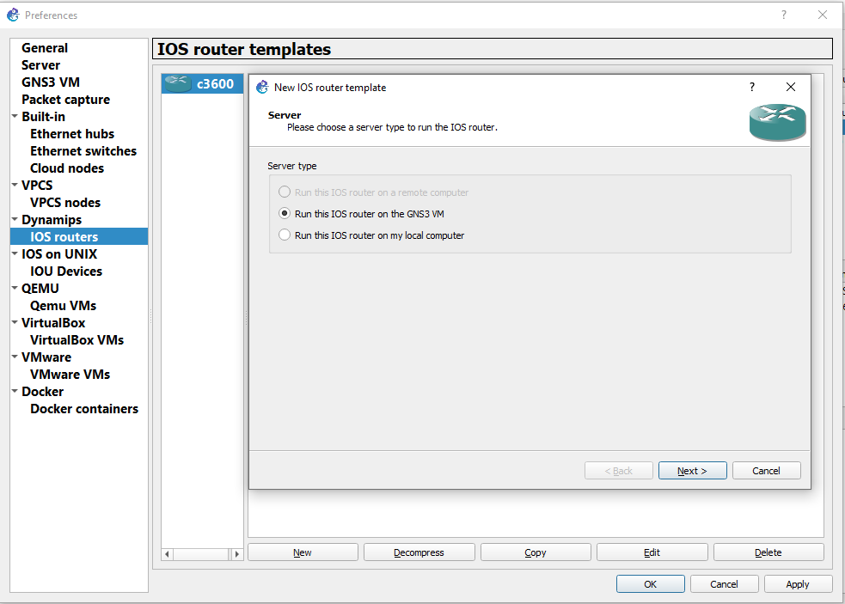

1. In the next window select **New Image** radio button and select the downloaded IOS image. Click No if asked to decompress the image. Click Next till the last window

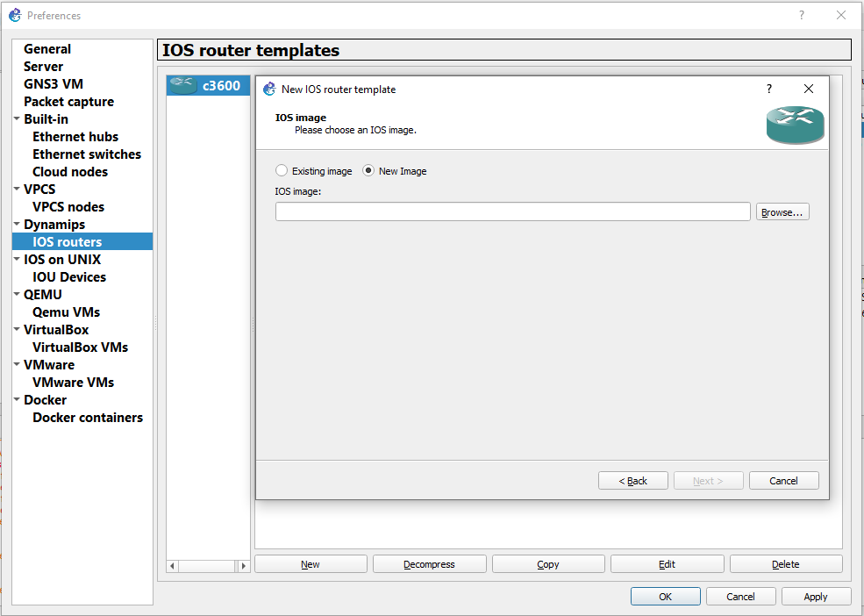

# **Importing Virtual Box VM in GNS3 GUI**

1. In order to import a VM in Virtual Box to GNS3.Go to **Edit -> Preferences.** Select VirtualBoxVMs in the left pane. Click New.

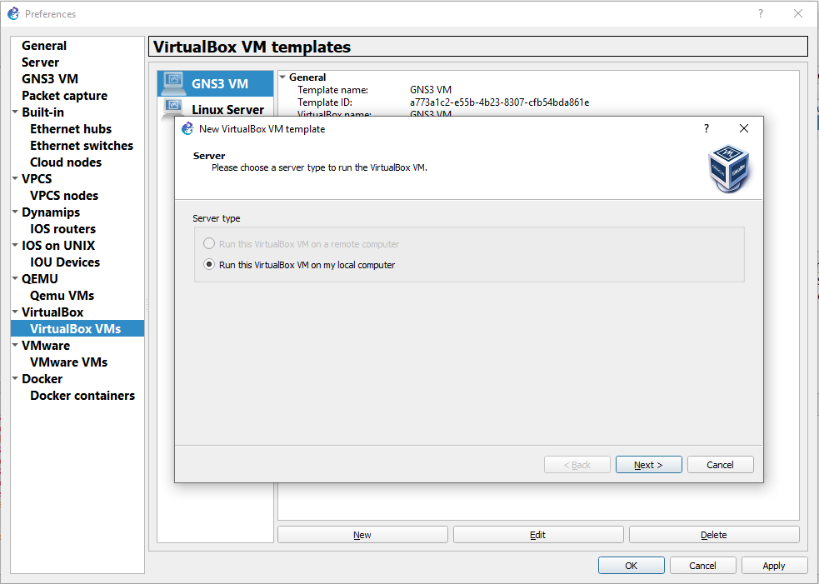

1. Select the option **Run this VirtualBox VM on my local Computer.** In the next window select the VM to be imported from the list of VMs available and click Finish.

# **SSH settings in Linux server**

Linux server can support SSH Version 2. So SSH Version 2 must be enabled in the Cisco Router.

**diffie-hellman-group1-sha1** used by Cisco IOS is not present in the default set of key exchange algorithms of Ubuntu 16.04. To enable that

1. Go to **/etc/ssh/ssh_config.**
2. Add the following line in the configuration file

